# Answers

# 1. Describe briefly three advantages of using subroutines in programs. [6]

Large programs are broken down into subtasks that are easier to program and manage

Each module can be individually tested and debugged

Modules can be re-used several times in a program

Frequently used modules can be saved in a library and used by other programs

Several programmers can simultaneously work on different modules, shortening development time

A well-organised, modular program is easier to follow

If the program needs to be modified, it is easier to find which module needs to be changed

Self-contained modules mean that the change should not affect the rest of the program

New features can be added by adding new modules

# 2. (a) What is a global variable? [1]

A variable that has scope anywhere in the program, including subroutines, without having to be passed as a parameter.

# (b) What is a local variable? [1]

A local variable only has scope within the routine in which it is used; it can’t be accessed elsewhere without being passed. The memory location is no longer available after the routine has finished running.

# (c) What is the advantage of using local variables in subroutines? [2]

# Using local variables keeps the subroutine independent of the main program, so that it can be used without inadvertently affecting any variables in the main program.

# 3. Write a program in pseudocode that allows the user to add a name to a list array that holds up to ten names. The main program should call a subroutine that presents the user with a menu of three choices:

# 1 Add name

# 2 Display list

# 3 Quit

# The subroutine accepts and validates the user choice (1-3). If it is invalid, an appropriate error message should be displayed and the user asked to re-enter until they input a valid choice.

The subroutine is called with the statement

choice = displayMenu()

The main program then branches to one of two subroutines which adds a name or displays the list, or quits the program with a message “Program terminating” if the user selects option 3.

# If the user chooses to add a name, they should be prompted to enter a list number indicating where they want the name to be inserted. If the location is occupied, it will overwrite the name.

# The program will also provide an option to display the list. The output should look something like the example below. [10]

# 

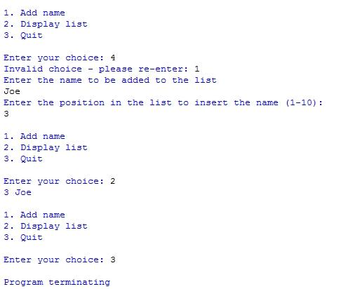

[Total 20 marks]

function displayMenu()

print(“1 Add Name”)

print(“2 Display list”)

print(“3 Quit”)

choice = input(“Enter choice: ”)

while choice < 1 OR choice > 3

choice = input(“Error… choice must be 1 to 3, please re-enter: ”)

endwhile

return choice

endfunction

procedure addName(names)

newName = input(“Enter name: ”)

index=input(“Enter position in the list to insert the name (1-10): ”)

names[index] = newName

endprocedure

procedure displayNames(names)

for index = 1 to 10

if names[index] not empty

print(names[index])

endif

next index

endprocedure

#main program

declare array names[1:10]

choice = 0

while choice != 3

choice = displayMenu()

if choice == 1 then

addName(names)

else if choice == 2 then

displayNames(names)

endif

endwhile

print(“Program terminating”)